~A000-US-Points-Paleo-Gainey Fluted -11,000 BP

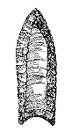

**Case No.: 11**

**Accession Number:**

**Formal Label:** US-Points-Paleo-Gainey Fluted-11,000 BP

**Display Description:**

**SIZE:** Measured points range from ca. 50-95 mm in length mean 68.4), 20-37 mm in width (mean 26.9), 6-8.5 mm in thickness (mean 7.6) and 19 to 32 in basal width (mean 26.1). Basal concavities tend to be deep (2-8.5; mean 4.9).

**SHAPE:** Gainey points lack fishtails. Although the lateral basal edges can expand slightly from the base to a maximum width around mid-point, the points are essentially parallel-sided. The points are relatively wide but are somewhat thick (width to thickness ratios ca. 3-4 to 1). Cross-sections are of a marked biconvex form.

**FLAKING:** Flaking is very similar to that for Barnes points, including: parallel-collateral retouch; a tendency for single, long, and parallel sided flute removals. Lateral basal edges are very heavily ground such that in some cases, and in plan views, a distinct quasi shoulder is formed at the juncture of the ground and unground areas.

**LC Classification:**

**Date or Time Horizon:** 11,000-9000 BP. No C-14 dates are available for Gainey points. They are dated to slightly more recent than 11,000 BP.

**Geographical Area:** These points definitely occur throughout southern Ontario, southern Michigan and northern Ohio. Their distribution beyond this area is unknown.

**Map:** *Megalloway* River Valley, ME, within the *Androscoggin* River Watershed, 1960.



Megalloway River in the Androgoggin River drainage after <https://www.bethelhistorical.org/legacy-site/Androscoggin%20watershed.jpg>

The Magalloway River in extreme NW ME and NE NH flows from an altitude of nearly 3,500 feet on the flanks of the Border Mountains on the international boundary between the United States and Canada down to the confluence of the outflow stream from Umbagog Lake—the lowest of several vast bodies of water in the Rangeley Lakes chain. The Magalloway River was an important transportation route for the Abenaki Indians who fished along its shores. It flows S to 2.5-mile (4.0 km)-long Parmachenee Lake to the 15-mile (24 km)-long Aziscohos Lake joining Umbagog Lake (Abenaki, "shallow-water" with an average depth of 10 ft or 3 m). Finally, it joins the Androscoggin River, which ultimately flows into the Atlantic Ocean. It was this trajectory that enabled the carriers of the Gainey Point flaking technique to be associated with the Abenaki ancestors at the Bull Brook site in Essex County, MA. These Abenaki ancestors were expert canoeists who were able to explore the NE coast and penetrate its interior.

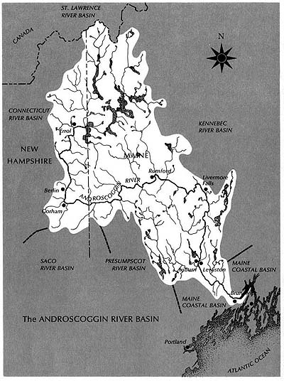

**GPS Coordinates:**

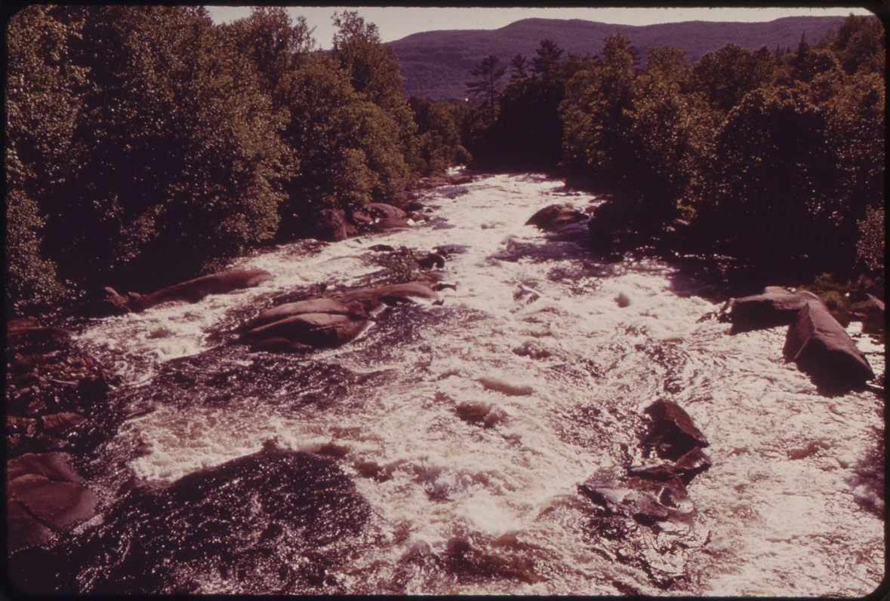

**Cultural Affiliation:** Paleo. The type site for these points is the Gainey site in south-central Michigan investigated by Don Simons (1984) but this point was early on discovered at the Bull Brook site in Essex County, MA. It was also discovered in the Great Lakes region (Roosa 1965) and in Ontario, which suggests that the Clovis-type fluting achieved its ultimate expression in these areas.

**Medium:**

Although some Gainey points are known on Collingwood chert, most of this type tend to be on "southern" cherts including Onondaga from Ontario and Upper Mercer, Flint Ridge and Tenmile Creek chert from Ohio.

**Dimensions**:   
**Weight:**

**Provenance:**

Megalloway River Valley, ME. 1960.

**Condition: original**

**Discussion:**

The flute of this point extends 50-85 percent up the face, which is the first distinguishing characteristic of this type and probably represents an eastern development of the Clovis point, in which fluting had become well-developed (Fowler 1972). The second distinguishing characteristic of this type is the basal concavity (Ellis and Deller 1997) from the deepest concavity at the Debert site and in a descending order to the Vail site, the Whipple site, Bull Brook, Gainey, and Shoop (Lavine and Sassamen, 1999).

The group of vocational archaeologists who excavated this point at Bull Brook, Essex County, MA, were not recognized or acknowledged by the Peabody Museum in Salem, MA, or the MA Archaeological Society during the ten-plus years the weekend “Bull Brookers” devoted to excavating this site (William Fowler Pers. Comm., 1992). As a consequence, much of the taphonomic data was either unrecorded or not recorded properly.   
  
Clovis style points, of which this is an example, vary in specific areas with variants in which size may have been allied to use (MacDonald 1968), but **References:**

Ellis and Deller (199

Fowler 1991. William S. Fowler and revised by Curtiss R. Huffman, (1991), *A Handbook of Indian Artifacts from Southern New England,* Special Publication #4, Massachusetts Archaeological Society

Lavine and Sassamen, 1999

MacDonald 1968

Roosa 1965